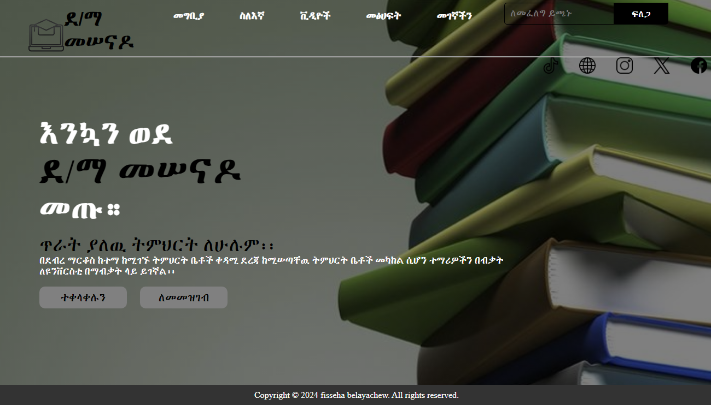

**D/M PREPARATORY WEB SOFTWARE DESCRIBTION**

**PREPARE BY:FISSEHA BELAYACHEW**

## INTRODUCTION

Welcome to software intro I pronounce **D/M preparatory** web software D/M preparatory the greatest school in D/M. partially advanced in tech and other thing inorder to solve these problem I build simple, effectively, easy to use and help students to get the whole thing at once software.

## BACKGROUND OF THE STUDY

I have been learning study software developing over year, and to solve our problems. I build many software like questioning app, puzzle game and now great school web software.

This inspired me to build **D/M preparatory** web software; students lack of access technology, complexity ,don’t get the whole thing at once. I researched on these things by asking many student problems, registration barriers and what they got satisfied to use .

## STETMENT OF THE PROBLEM

In our world has many problem and advancement of technology solve these problem early up to now.

So our school problems are registration barriers, lack of access technology, demand for advanced study tip and guidance( like books ,videos ),demand to access admnistrion office( phone number, po.box and many other problem .)

## QUASTION?

**1.what students want ?**

Many student want to access the technology. To get books ,study tips and guidance video ,extraordinary books in general refer to the use of information and communication technologies for facilitating the teaching learning process. This software is provided over the Internet, it is referred to as online learning and other .

**2.what parents and teacher want from this technology?**

parents and teacher want the students learn more effectively ,bitterly, and in advance way inorder to students get best result

**3. what is the benefit of D/M preparatory** web software **for students?**

• Flexibility in learning time: Learners can access and learn at any time, or any day. • Implementation of student-centered learning: Learners can learn on their own pace. • Access to a variety of educational resources from different schools or universities • Rich multimedia learning resources: The multimedia e-learning content engages learners to be active learners. • Reduced educational costs: there are no costs for travel and accommodation

## GENERAL AND SPASIFIC OBJECTIVE

The major aim to build **D/M preparatory** web software to solve all problem of students ,teachers ,and parents. In efficient and productive way by providing use of information and communication technologies for facilitating the teaching learning process.

This software is provided over the Internet, it is referred to as online learning , online registration, online liberary, online contacting to the teachers etc.

## CONCULTION

This **D/M preparatory** web software solve above problems and students learn In effective way by Access to a variety of educational resources from different schools or universities , Rich multimedia learning resources and they got a best result, motivate to learn.

=thank you=